Placement project
How a social worker can use canine-assisted interventions and therapies to assist trauma-surviving students within a school environment.

Introduction
Successful social work practice in a school setting requires the ability to function within diverse frameworks, structures, policies, and procedures when interacting with students and co-workers. Animal-assisted programs are becoming increasingly popular with schools and clinical settings, particularly using dogs as the assistant. While there are some risks associated with working with dogs, the benefits outweigh the risks. This paper will discuss what a school social worker can offer a school, the different kinds of trauma and the impact on teenagers, what animal-assisted therapies and interventions are, barriers to implementing school-based animal-assisted therapies, and the risks and benefits associated with animal-assisted therapy in a school setting.

Social work
The Australian Association of Social Workers (AASW) is the professional representative body for Australian social workers. It governs the conduct of social workers through a Code of Ethics, various Scopes of Practice, and sets the standard for education for and credentialing of Australian social workers (AASW, 2021). The organisation adheres to the definition of a social worker as given by the International Federation of Social Workers and International Association of Schools of Social Work in 2014.
Social work is a practice-based profession and an academic discipline that promotes social change and development, social cohesion, and the empowerment and liberation of people. Principles of social justice, human rights, collective responsibility and respect for diversities are central to social work. Underpinned by theories of social work, social sciences, humanities and indigenous knowledge, social work engages people and structures to address life challenges and enhance wellbeing (AASW, 2020).

According to the AASW, social workers play a vital role in assisting some of the most vulnerable individuals, families, groups, communities within society (AASW, 2020). This role is undertaken in various settings, but they are all grounded on social work principles of social justice, human rights, and respect for human dignity. Within a school setting, the role is unique. A social worker can be available, in partnership with other school personnel, to promote positive educational outcomes by helping to relieve emotional distress and encourage a safe and inclusive school community (AASW, 2020). A social worker can assist decision-makers within the school environment to address issues relating to non-attendance, school refusal, and matters relating to following the school’s procedures relating to discipline.
Social workers use various interpersonal skills to interact with students, teachers, and other school staff, including communication, empathy, flexibility, resilience, and optimism. These skills are used to build rapport with others, which engenders trust between the social worker and client (Healy, 2014). Australia is a highly diverse society, encompassing people from many different racial and ethnic backgrounds. Poverty, disabilities, and puberty will inevitably impact teenagers and, therefore, their ability to learn. Add in surviving traumatic life events, such as witnessing domestic violence, living in out-of-home care, or living with a mental health condition, gaining an education can become even more difficult for some students. This difficulty can lead students to disengage from traditional schools, or be expelled from traditional schools that cannot manage extreme trauma-based behaviours. Under such circumstances, a school such as Ohana College, formerly The Spot Academy, can be beneficial.

Trauma
Trauma can be defined as a type of damage to the mind that can occur after an event that a person finds physically or emotionally threatening or harmful (Leonard, 2020). Trauma comes in many forms, including but not limited to physical and emotional, and it affects everybody differently. Trauma can be: acute, stemming from a single, dangerous event; chronic, stemming from repeated and prolonged exposure to events; and complex, stemming from multiple events (Leonard, 2020). With up to 57% of Australians having experienced some form of traumatic event in their lives (Open Minds, 2019), it is essential to understand the impact that it can have, particularly on teenagers. If not addressed correctly, this damage done to the mind, has the potential to lead to a psychosocial disability (Open Minds, 2019), such as post-traumatic stress disorder (PTSD), or other mental health conditions such as anxiety, depression, or create substance misuse issues (Leonard, 2020).
Recovery from trauma is possible, but often, the survivor needs help. When the survivor of trauma is a child or teenager, the trauma will affect the brain development and, therefore, their behaviour (Libertin, 2019). At a time when a teenager is already experiencing significant biological and social changes, trauma creates new survival patterns in the brain that teach the person how to fulfil their needs. However, once that person is in a place of safety, especially when the trauma has been chronic or complex, the person’s brain has forged neural pathways that can lead to maladaptive behaviours (Libertin, 2019). Another manifestation is that a child or teenage survivor may have issues with memory and cognition which affects their sense of self, their ability to build relationships, and their ability to learn (Libertin, 2019). This is where animal-assisted therapies and animal-assisted interventions in a school can help, in conjunction with trauma-based therapies and social-skills training (Jones, Rice, & Cotton, 2018). It is essential to involve the therapy animal as a co-therapist, not a source of therapy in itself (Jones et al, 2018). The animal is used to enhance treatment by encouraging engagement, improving rapport between client and social worker, and reducing acute emotional arousal (Jones, et al, 2018).

Benefits of animal-assisted therapies and interventions
There are many forms of animal-assisted therapies (AAT) and animal-assisted interventions (AAI) available, but the most practical for a suburban school, would be those offered using dogs. While AAT and AAI currently do not fall under the scope of the AASW policy due to “heightened risk provisions” and insurance implications, they are a valid source of therapeutic interventions and are becoming more common. While there is a perception that a dog can be a risk to the general public therapy dogs are trained specifically to work with their handler in a therapeutic setting (Therapy Dogs Australia, 2021). With AASW membership, a social worker is provided practice insurance, but the AASW cannot offer insurance for AAT and AAI, as it would increase membership costs. It is, however, possible for a handler to obtain their own public liability insurance for the animal with which they are working, if the organisation the social worker practices with, does not provide it to them.
Teenagers have the right to meaningful, relevant, and effective interventions at a time and in a location that they need them. Sometimes that need takes place while they are at school, and therefore, the intervention needs to be immediate. A therapy dog is trained to respond to other people at its handler's direction (Ketchell, 2018). The dog’s response to these directions can help build rapport with a student as they interact to break down barriers between the student and social worker, help the student build self-regulating behaviours, and offer comfort to distressed students (Therapy Dogs Australia, 2021).
AAT and AAI offer a unique form of support to students in an educational setting (Friesen, 2009). The Psych Professionals (2019) state that some benefits include, but are not limited to:
- Reduced anxiety in a client
- Non-threatening environment
- Modelling, and
- It can be an enjoyable experience for all involved.
AAT and AAI are able to assist with managing mental health conditions such as anxiety, depression, behavioural disorders such as attention deficit hyperactivity disorder (ADHD) and oppositional defiant disorder (ODD), anger management, emotional regulation, and social skill development (The Psych Professionals, 2019). Dogs can also help rebalance power issues between student and adult as they are perceived as non-judgmental, and therefore safe if a student makes a mistake. The dog helps the student interact with others in the school through the dog’s unconditional support, the dog’s desire for interaction with others, or the dog’s positive interactions with those around the student (Friesen, 2009).
According to Anthony Barnett (TedX Talk, 2015), the Animal Assisted Therapy Model involves taking a person with a specific need and pairing them with a trained dog for a particular purpose to achieve a specific outcome.
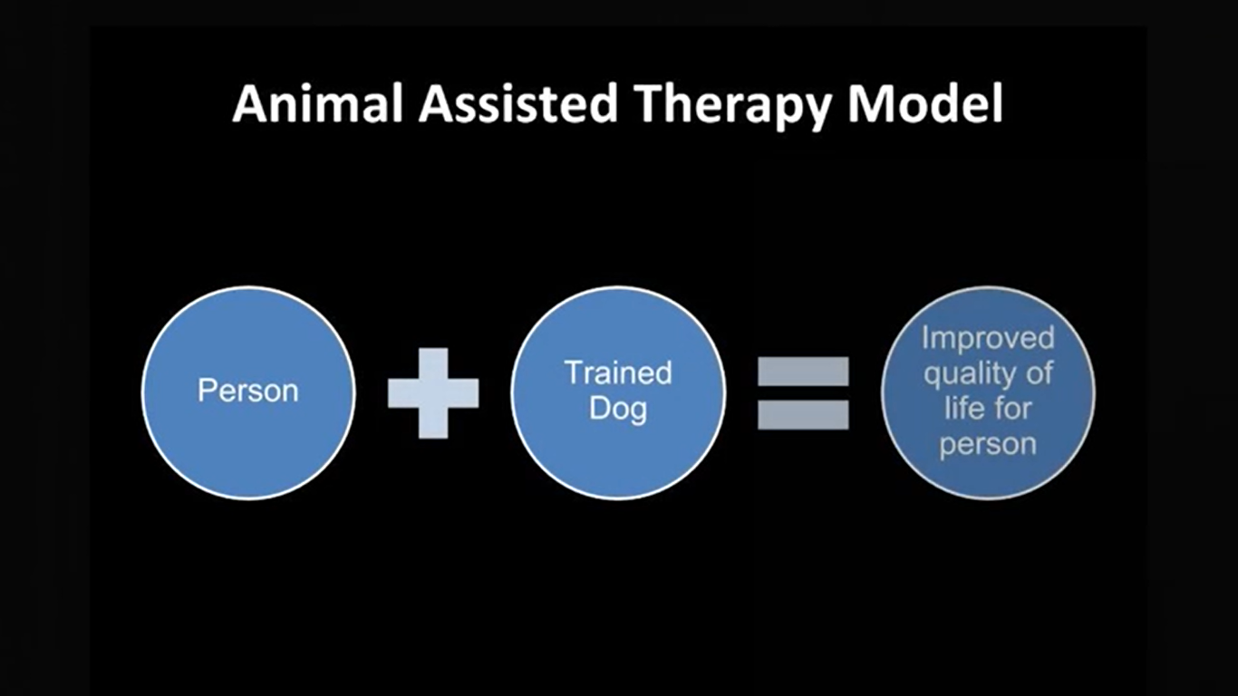

Using this model can help improve the social and emotional wellbeing of students in school by enabling them to see the social worker as less threatening, which increases the positive rapport (Ketchell, 2018). Studies over the last twenty years have revealed the positive effects a dog can have on an individual's physiology, including their cortisol levels, heart rate, blood pressure, self-reported levels of fear, and anxiety (Beetz, Uvnäs-Moberg, Julius, & Kotrschal, 2012). Students often perceive dogs to be non-judgmental, allowing the students to find a unique relationship in their educational setting (Friesen, 2009).

Risks
According to Friesen (2009), some concerns that can be raised in relation to having a dog in a school are:
- Zoonoses – the risk of a disease that is transferable between human and animal
- The potential for people with an allergy to canine dander
- Safety for students, staff, and the dog, and
- Cultural safety.

The risk of zoonoses is small. However, thorough hand-washing is always encouraged, and hand sanitiser should be available before and after sessions with the dog (The Psych Professionals, 2019). The possibility of allergies can be minimised with the careful selection of an animal that sheds minimally and is groomed regularly, and has regular access to medical care, such as regular worming and vaccinations (Friesen, 2009). While dog bites to children can be common in the general population, students can have lessons in how to interact appropriately with a dog to avoid injuries to the student and the dog, learn to be empathetic to the dog’s needs, learn how to play fairly with the dog, and actions the student should take if they are afraid of the dog (Friesen, 2009). In conducting these lessons, students learn correct human-canine interactions, and also gives the student the opportunity to self-regulate before being able to approach the dog. If parents or guardians are still concerned about safe interactions, they could be offered the opportunity to see for themselves how well groomed, how well trained, and how closely the dog is monitored during interactions with students (Friesen, 2009). However, in some cultures, particularly of some Middle-Eastern or Asian cultures, dogs are perceived as ‘unclean’ (Jalongo et al, 2004, cited in Friesen, 2009). It is therefore, essential that it be made clear to all families, that a dog will be on campus, so that informed consent can be given by both the parents or guardians and the student, and that at no time will the student be forced to interact with the dog.

Ethical treatment of the dog
Therapy dogs are dogs who live with their handler, and when they are “off-duty”, return to being the handler’s pet. The dogs are kept to a high hygiene and health standard (The Psych Professionals, 2019), and the dog and handler team are trained to a high standard. The Animal Assisted Intervention International Standards of Practice (2019) sets the minimum ethical standard for therapy dogs. This addresses the ethical treatment of the dog for both inside and outside of its working hours. Outside of working time, the dog is entitled to:
- Safe transport to and from school
- Regular medical attention
- Regular grooming
- Freedom from thirst, hunger, and malnutrition
- Freedom from discomfort, pain, injury, and illness
- Freedom from fear and distress, including force-free training, and
- Freedom to express normal dog behaviours, especially when interacting with other dogs.
During working hours, the dog still has rights and needs that need to be fulfilled. Some of the things that the dog needs to have available are:
- Water
- A safe space to rest, away from students when it needs a break
- Exercise and toilet breaks
- Clean equipment, such as toys, blankets, and bowls
- To be treated gently by those interacting with the dog, and
- Be comfortable wearing any identification that marks them as a therapy dog.

Barriers to implementation
Depending on the organisation through which the handler chooses to be certified, the team are reassessed every twelve months, to ensure continued safe and ethical work (Therapy Dogs Australia, 2021). It is a highly involved and expensive process, that requires a high level of commitment by the handler, dog, and organisation that the handler may work for. For example, Therapy Dogs Australia provides two types of training, including one for training for clinical practitioners. To begin the journey to becoming a practitioner, the theoretical course content provided by Therapy Dogs Australia is presented in the six hour Introductory Course, at a cost of $269.50, conducted by Zoom includes:
- What is Animal Assisted Therapy – What it is and what it is not
- What is the Human-Animal Bond?
- Which species can be worked with?
- Ethical considerations – for you, your participant, and your animal
- Legal considerations
- Animal selection and training standards, and
- Logistics – what do you need to consider.
This is followed by a Pre-Course Consultation, at a cost of $250, to determine if the handler’s existing dog is suitable for therapeutic work. This is then followed by training with a cost of $150 for each of the dog’s obedience assessment and the temperament assessment. For a therapist undertaking a Clinical Course over five weeks, the cost is $2000 plus the following assessment cost of $300. Some of the theory that is covered in the course includes:
- ​Clinical case studies
- Intervention training
- Insurance requirements
- Funding options & restrictions
- Client & Canine ethical considerations
- Application of theoretical perspectives
- Review of available research, and
- Real World Training.

Upon completion of clinical training, depending on the age of the dog, the dog graduates either as a Learner, if under the age of one year, or as a Level 1, if over the age of one year. The dog is issued with a Therapy Dog bandana and certificate, that has an expiry date. As a result of the costs and complicated process, there is a lack of trained therapy teams which can limit the availability of therapy dogs.
There is also division in research circles as to the efficacy of AAI and AAT due to the lack of standardised research, practice guidelines, and clinical governance (Jones, et al, 2018). This leads to conflicting literature. Social workers follow practice standards that are “designed to guide social workers’ practice to ensure they fulfill the practice requirements as set out by the AASW” (AASW, 2013). ‘Knowledge for practice’ is embedded within these practice standards. Social workers are required to practice using evidence-based practice, meaning all therapeutic interventions must be based on quality research. However, there are five types of knowledge, including practice wisdom which is gained through practice experience (Cleak & Wilson, 2013). Therefore, with the number of studies that have been released supporting animal-assisted therapies and interventions, it can be argued that the appropriate use of animals is a valid therapeutic tool.

Conclusion
In conclusion, school-based social workers hold a unique role within schools, grounded on principles of social justice, human rights, and respect for human dignity. Social workers partner with other members of school staff to address student’s issues such as non-attendance and the like. Using their interpersonal skills, social workers build rapport with students and staff, and sometimes one of their tools is using a therapy dog. It has been established in some research, that dogs as co-therapists in a school setting are generally beneficial to students. While the handler is still involved in the interactions between the dog and child, students perceive the social worker more positively, encouraging self-regulating behaviours from the student which in turn, enables learning. While there are some perceived risks involved with having a dog on-campus, the risks can be managed, with better outcomes for the student. While there is division by researchers as to the efficacy of AAI and AAT, practice wisdom presented by many practitioners shows the validity of involving dogs in practice.

References

Australian Association of Social Workers. (2013). Practice Standards. Retrieved from https://www.aasw.asn.au/document/item/4551

Australian Association of Social Workers. (2020). Scope of Social Work Practice: School Social Work. Retrieved from https://www.aasw.asn.au/document/item/8308

Australian Association of Social Workers. (2021). Regulation of Social Work in Australia. Retrieved from https://www.aasw.asn.au/social-policy-advocacy/regulation-of-social-work-in-australia

Beetz, A., Uvnäs-Moberg, K., Julius, H., & Kotrschal, K. (2012). Psychosocial and Psychophysiological Effects of Human-Animal Interactions: The Possible Role of Oxytocin. Frontiers in Psychology, 3(234), doi: 10.3389/fpsyg.2012.00234

Cleak, H. & Wilson, J. (2013). Making The Most Of Field Placement (3rd ed.). South Melbourne, Victoria: Cengage Learning.

Friesen, L. (2009). Exploring Animal-Assisted Programs with Children in School and Therapeutic Contexts. Early Childhood Educ J, (37). 261-267 DOI 10.1007/s10643-009-0349-5

Healy, K. (2014). Social Work Theories in Context: Creating frameworks for practice (2nd ed.). London, England: Palgrave Macmillan.

Jones, M. G., Rice, S. M., & Cotton, S. M. (2018). Who let the dogs out? Therapy dogs in clinical practice. Australasian Psychiatry, 26(2), 196-199. Australasian Psychiatry 2018, Vol 26(2) 196–199. DOI: 10.1177/1039856217749056

Ketchell, M. (2018, March 20). Therapy dogs can reduce student stress, anxiety and improve school attendance. The Conversation. Retrieved from https://theconversation.com/therapy-dogs-can-help-reduce-student-stress-anxiety-and-improve-school-attendance-93073

Leonard, J. (2020, June 3). What is Trauma? What to know. Medical News Today. Retrieved from https://www.medicalnewstoday.com/articles/trauma

Libertin, A. (2019). The Teen Years: Brain Development and Trauma Recovery. Retrieved from https://www.nacac.org/resource/the-teen-years-brain-development-and-trauma-recovery/#:~:text=Similarly%2C%20when%20a%20child%20faces,or%20more%20critical%20thinking%20shrink.

Open Minds. (2019). Understanding Trauma and PTSD. Retrieved from https://openminds.org.au/news/understanding-trauma-and-ptsd?gclid=Cj0KCQjwsLWDBhCmARIsAPSL3_3IypLOTAC_Z6EeLmGyAThc4JLY4vjGovsESnP2NJz93bZTg2-i0SwaAtkKEALw_wcB

TEDx Talks. (2015, May 30). Human-canine healing [Video file]. Retrieved from https://www.youtube.com/watch?v=zK2HD9a2EjQ

The Psych Professionals. (2019). Animal Assisted Therapy. Retrieved from https://psychprofessionals.com.au/services/animal-assisted-therapy/

Therapy Dogs Australia. (2021). What is Animal Assisted Therapy? Retrieved from https://therapydog.com.au/what-is-aat%3F

